SQL

(Notes by Apna College)

What is Database?

Database is a collection of interrelated data.
- A database is an application that stores the organized collection of records.
- It can be accessed and manage by the user very easily.
- It allows us to organize data into tables, rows, columns, and indexes to find the relevant information very quickly.
- Each database contains distinct API for performing database operations such as creating, managing, accessing, and searching the data it stores.
- Today, many databases available like MySQL, Sybase, Oracle, MongoDB, PostgreSQL, SQL Server, etc. In this section, we are going to focus on MySQL mainly.

What is DBMS?

DBMS (Database Management System) is software used to create, manage, and organize databases.

What is RDBMS?

- RDBMS (Relational Database Management System) - is a DBMS based on the concept of tables (also called relations).
- Data is organized into tables (also known as relations) with rows (records) and columns (attributes).
- Eg - MySQL, PostgreSQL, Oracle etc.

What is SQL?

SQL is Structured Query Language - used to store, manipulate and retrieve data from

RDBMS.

(It is not a database, it is a language used to interact with database)

We use SQL for CRUD Operations :

- CREATE - To create databases, tables, insert tuples in tables etc

- READ - To read data present in the database.

- UPDATE - Modify already inserted data.

- DELETE - Delete database, table or specific data point/tuple/row or multiple rows.

*Note - SQL keywords are NOT case sensitive. Eg: select is the same as SELECT in SQL.

SQL v/s MySQL

SQL is a language used to perform CRUD operations in Relational DB, while MySQL is a RDBMS that uses SQL.
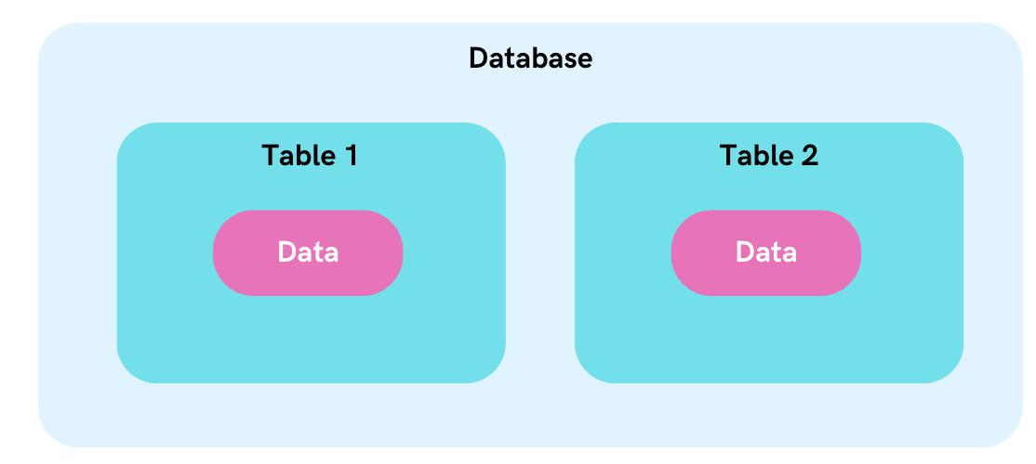
SQL Data Types

In SQL, data types define the kind of data that can be stored in a column or variable.

To See all data types of MYSQL, visit :

https://dev.mysql.com/doc/refman/8.0/en/data-types.html

Here are the frequently used SQL data types:

DATATYPE | DESCRIPTION | USAGE
CHAR | string(0-255), can store characters of fixed length | CHAR(50)
VARCHAR | string(0-255), can store characters up to given length | VARCHAR(50)
BLOB | string(0-65535), can store binary large object | BLOB(1000)
INT | integer( -2,147,483,648 to 2,147,483,647 ) | INT
TINYINT | integer(-128 to 127) | TINYINT
BIGINT | integer( -9,223,372,036,854,775,808 to | BIGINT
 | 9,223,372,036,854,775,807 )
BIT | can store x-bit values. x can range from 1 to 64 | BIT(2)
FLOAT | Decimal number - with precision to 23 digits | FLOAT
DOUBLE | Decimal number - with 24 to 53 digits | DOUBLE
BOOLEAN | Boolean values 0 or 1 | BOOLEAN
DATE | date in format of YYYY-MM-DD ranging from | DATE
 | 1000-01-01 to 9999-12-31
TIME | HH:MM:SS | TIME
YEAR | year in 4 digits format ranging from 1901 to 2155 | YEAR

*Note - CHAR is for fixed length & VARCHAR is for variable length strings. Generally, VARCHAR is better as it only occupies necessary memory & works more efficiently.

We can also use UNSIGNED with datatypes when we only have positive values to add. Eg - UNSIGNED INT

Types of SQL Commands:

- DQL (Data Query Language) : Used to retrieve data from databases. (SELECT)

- DDL (Data Definition Language) : Used to create, alter, and delete database objects like tables, indexes, etc. (CREATE, DROP, ALTER, RENAME, TRUNCATE).

- DML (Data Manipulation Language): Used to modify the database. (INSERT,

UPDATE, DELETE)

- DCL (Data Control Language): Used to grant & revoke permissions. (GRANT,

REVOKE)

- TCL (Transaction Control Language): Used to manage transactions. (COMMIT,

ROLLBACK, START TRANSACTIONS, SAVEPOINT)

1. Data Definition Language (DDL)

Data Definition Language (DDL) is a subset of SQL (Structured Query Language) responsible for defining and managing the structure of databases and their objects.

DDL commands enable you to create, modify, and delete database objects like tables, indexes, constraints, and more.

Key DDL Commands are:

- CREATE TABLE:

  - Used to create a new table in the database.

  - Specifies the table name, column names, data types, constraints, and more.

  - Example:

CREATE TABLE employees (id INT PRIMARY KEY, name VARCHAR(50), salary DECIMAL(10, 2));

- ALTER TABLE:

  - Used to modify the structure of an existing table.

  - You can add, modify, or drop columns, constraints, and more.

  - Example: ALTER TABLE employees ADD COLUMN email VARCHAR(100);

- DROP TABLE:

  - Used to delete an existing table along with its data and structure.

  - Example: DROP TABLE employees;

- CREATE INDEX:

  - Used to create an index on one or more columns in a table.

  - Improves query performance by enabling faster data retrieval.

  - Example: CREATE INDEX idx_employee_name ON employees (name);

- DROP INDEX:

  - Used to remove an existing index from a table.

  - Example: DROP INDEX idx_employee_name;

- CREATE CONSTRAINT:

  - Used to define constraints that ensure data integrity.

  - Constraints include PRIMARY KEY, FOREIGN KEY, UNIQUE, NOT NULL, and CHECK.

  - Example: ALTER TABLE orders ADD CONSTRAINT fk_customer FOREIGN KEY (customer_id) REFERENCES customers(id);

- DROP CONSTRAINT:

  - Used to remove an existing constraint from a table.

  - Example: ALTER TABLE orders DROP CONSTRAINT fk_customer;

- TRUNCATE TABLE:

  - Used to delete the data inside a table, but not the table itself.

  - Syntax – TRUNCATE TABLE table_name

2. DATA QUERY/RETRIEVAL LANGUAGE (DQL or DRL)

DQL (Data Query Language) is a subset of SQL focused on retrieving data from databases.

The SELECT statement is the foundation of DQL and allows us to extract specific columns from a table.

- SELECT:

The SELECT statement is used to select data from a database.
Syntax: SELECT column1, column2, ... FROM table_name;

Here, column1, column2, ... are the field names of the table.

If you want to select all the fields available in the table, use the following syntax:

SELECT * FROM table_name;

Ex: SELECT CustomerName, City FROM Customers;

- WHERE:

The WHERE clause is used to filter records.

Syntax: SELECT column1, column2, ... FROM table_name WHERE condition;

Ex: SELECT * FROM Customers WHERE Country='Mexico';

Operators used in WHERE are:

= : Equal

- : Greater than < : Less than
>= : Greater than or equal

<= : Less than or equal

<> : Not equal.

Note: In some versions of SQL this operator may be written as !=

- AND, OR and NOT:

- The WHERE clause can be combined with AND, OR, and NOT operators.

- The AND and OR operators are used to filter records based on more than one condition:

- The AND operator displays a record if all the conditions separated by AND are TRUE.

- The OR operator displays a record if any of the conditions separated by OR is TRUE.

- The NOT operator displays a record if the condition(s) is NOT TRUE.

Syntax:
SELECT column1, column2, ... FROM table_name WHERE condition1 AND condition2 AND condition3 ...;

SELECT column1, column2, ... FROM table_name WHERE condition1 OR condition2 OR condition3 ...;

SELECT column1, column2, ... FROM table_name WHERE NOT condition;

Example:

SELECT * FROM Customers WHERE Country=’India’ AND City=’Japan’;

SELECT * FROM Customers WHERE Country=’America’ AND (City=’India’ OR City=’Korea’);

- DISTINCT:

Removes duplicate rows from query results.

Syntax: SELECT DISTINCT column1, column2 FROM table_name;

- LIKE:

The LIKE operator is used in a WHERE clause to search for a specified pattern in a column.

There are two wildcards often used in conjunction with the LIKE operator:

- The percent sign (%) represents zero, one, or multiple characters

- The underscore sign (_) represents one, single character

Example: SELECT * FROM employees WHERE first_name LIKE 'J%';

WHERE CustomerName LIKE 'a%'

- Finds any values that start with "a"

WHERE CustomerName LIKE '%a'

- Finds any values that end with "a"

WHERE CustomerName LIKE '%or%'

- Finds any values that have "or" in any position

WHERE CustomerName LIKE '_r%'

- Finds any values that have "r" in the second position
WHERE CustomerName LIKE 'a_%'

- Finds any values that start with "a" and are at least 2 characters in length

WHERE CustomerName LIKE 'a__%'

- Finds any values that start with "a" and are at least 3 characters in length

WHERE ContactName LIKE 'a%o'

- Finds any values that start with "a" and ends with "o"

- IN:

Filters results based on a list of values in the WHERE clause.

Example: SELECT * FROM products WHERE category_id IN (1, 2, 3);

- BETWEEN:

Filters results within a specified range in the WHERE clause.

Example: SELECT * FROM orders WHERE order_date BETWEEN '2023-01-01' AND '2023-06-30';

- IS NULL:

Checks for NULL values in the WHERE clause.

Example: SELECT * FROM customers WHERE email IS NULL;

- AS:

Renames columns or expressions in query results.

Example: SELECT first_name AS "First Name", last_name AS "Last Name" FROM employees;

- ORDER BY

The ORDER BY clause allows you to sort the result set of a query based on one or more columns.

Basic Syntax:

- The ORDER BY clause is used after the SELECT statement to sort query results.
- Syntax: SELECT column1, column2 FROM table_name ORDER BY column1 [ASC|DESC];

Ascending and Descending Order:

- By default, the ORDER BY clause sorts in ascending order (smallest to largest).

- You can explicitly specify descending order using the DESC keyword.

- Example: SELECT product_name, price FROM products ORDER BY price DESC;

Sorting by Multiple Columns:

- You can sort by multiple columns by listing them sequentially in the ORDER BY clause.
- Rows are first sorted based on the first column, and for rows with equal values, subsequent columns are used for further sorting.
- Example: SELECT first_name, last_name FROM employees ORDER BY last_name, first_name;

Sorting by Expressions:

- It's possible to sort by calculated expressions, not just column values.

- Example: SELECT product_name, price, price * 1.1 AS discounted_price FROM products ORDER BY discounted_price;

Sorting NULL Values:

- By default, NULL values are considered the smallest in ascending order and the largest in descending order.
- You can control the sorting behaviour of NULL values using the NULLS FIRST or NULLS LAST options.
- Example: SELECT column_name FROM table_name ORDER BY column_name

NULLS LAST;

Sorting by Position:

- Instead of specifying column names, you can sort by column positions in the ORDER BY clause.
- Example: SELECT product_name, price FROM products ORDER BY 2 DESC, 1 ASC;

- GROUP BY

The GROUP BY clause in SQL is used to group rows from a table based on one or more columns.

Syntax:
- The GROUP BY clause follows the SELECT statement and is used to group rows based on specified columns.

- Syntax: SELECT column1, aggregate_function(column2) FROM table_name GROUP BY column1;

- Aggregation Functions:

  - Aggregation functions (e.g., COUNT, SUM, AVG, MAX, MIN) are often used with GROUP BY to calculate values for each group.
  - Example: SELECT department, AVG(salary) FROM employees GROUP BY department;
- Grouping by Multiple Columns:

  - You can group by multiple columns by listing them in the GROUP BY clause.

  - This creates a hierarchical grouping based on the specified columns.

  - Example: SELECT department, gender, AVG(salary) FROM employees GROUP BY department, gender;

- HAVING Clause:

  - The HAVING clause is used with GROUP BY to filter groups based on aggregate function results.
  - It's similar to the WHERE clause but operates on grouped data.

  - Example: SELECT department, AVG(salary) FROM employees GROUP BY department HAVING AVG(salary) > 50000;

- Combining GROUP BY and ORDER BY:

  - You can use both GROUP BY and ORDER BY in the same query to control the order of grouped results.
  - Example: SELECT department, COUNT(*) FROM employees GROUP BY department ORDER BY COUNT(*) DESC;

- AGGREGATE FUNCTIONS

These are used to perform calculations on groups of rows or entire result sets. They provide insights into data by summarising and processing information.

Common Aggregate Functions:

- COUNT():

Counts the number of rows in a group or result set.

- SUM():

Calculates the sum of numeric values in a group or result set.

- AVG():
Computes the average of numeric values in a group or result set.

- MAX():

Finds the maximum value in a group or result set.

- MIN():

Retrieves the minimum value in a group or result set.

3. DATA MANIPULATION LANGUAGE

Data Manipulation Language (DML) in SQL encompasses commands that manipulate data within a database. DML allows you to insert, update, and delete records, ensuring the accuracy and currency of your data.

- INSERT:

- The INSERT statement adds new records to a table.

- Syntax: INSERT INTO table_name (column1, column2, ...) VALUES (value1, value2,

...);

- Example: INSERT INTO employees (first_name, last_name, salary) VALUES ('John', 'Doe', 50000);

- UPDATE:

- The UPDATE statement modifies existing records in a table.

- Syntax: UPDATE table_name SET column1 = value1, column2 = value2, ... WHERE condition;
- Example: UPDATE employees SET salary = 55000 WHERE first_name = 'John';

- DELETE:

- The DELETE statement removes records from a table.

- Syntax: DELETE FROM table_name WHERE condition;

- Example: DELETE FROM employees WHERE last_name = 'Doe';

4. Data Control Language (DCL)

DCL commands are used to control who can access the data, modify the data, or perform administrative tasks within a database.

DCL is an important aspect of database security, ensuring that data remains protected and only authorised users have the necessary privileges.

There are two main DCL commands in SQL: GRANT and REVOKE.

1. GRANT:

The GRANT command is used to provide specific privileges or permissions to users or roles. Privileges can include the ability to perform various actions on tables, views, procedures, and other database objects.

Syntax:

GRANT privilege_type

ON object_name

TO user_or_role;

In this syntax:

- privilege_type refers to the specific privilege or permission being granted (e.g.,

SELECT, INSERT, UPDATE, DELETE).

- object_name is the name of the database object (e.g., table, view) to which the privilege is being granted.

- user_or_role is the name of the user or role that is being granted the privilege.

Example: Granting SELECT privilege on a table named "Employees" to a user named "Analyst":

GRANT SELECT ON Employees TO Analyst;

2. REVOKE:

The REVOKE command is used to remove or revoke specific privileges or permissions that have been previously granted to users or roles.

Syntax:

REVOKE privilege_type

ON object_name
FROM user_or_role;

In this syntax:

- privilege_type is the privilege or permission being revoked.

- object_name is the name of the database object from which the privilege is being revoked.

- user_or_role is the name of the user or role from which the privilege is being revoked.

Example: Revoking the SELECT privilege on the "Employees" table from the "Analyst" user:

REVOKE SELECT ON Employees FROM Analyst;

DCL and Database Security:

DCL plays a crucial role in ensuring the security and integrity of a database system.

By controlling access and permissions, DCL helps prevent unauthorised users from tampering with or accessing sensitive data. Proper use of GRANT and REVOKE commands ensures that only users who require specific privileges can perform certain actions on database objects.

5. Transaction Control Language (TCL)

Transaction Control Language (TCL) deals with the management of transactions within a database.
TCL commands are used to control the initiation, execution, and termination of transactions, which are sequences of one or more SQL statements that are executed as a single unit of work.
Transactions ensure data consistency, integrity, and reliability in a database by grouping related operations together and either committing or rolling back changes based on the success or failure of those operations.

There are three main TCL commands in SQL: COMMIT, ROLLBACK, and SAVEPOINT.

1. COMMIT:

The COMMIT command is used to permanently save the changes made during a transaction.
It makes all the changes applied to the database since the last COMMIT or ROLLBACK command permanent.
Once a COMMIT is executed, the transaction is considered successful, and the changes are made permanent.

Example: Committing changes made during a transaction:

UPDATE Employees

SET Salary = Salary * 1.10

WHERE Department = 'Sales';

COMMIT;

2. ROLLBACK:

The ROLLBACK command is used to undo changes made during a transaction.

It reverts all the changes applied to the database since the transaction began.

ROLLBACK is typically used when an error occurs during the execution of a transaction, ensuring that the database remains in a consistent state.

Example: Rolling back changes due to an error during a transaction:

BEGIN;

UPDATE Inventory

SET Quantity = Quantity - 10

WHERE ProductID = 101;

- An error occurs here

ROLLBACK;

3. SAVEPOINT:

The SAVEPOINT command creates a named point within a transaction, allowing you to set a point to which you can later ROLLBACK if needed.

SAVEPOINTs are useful when you want to undo part of a transaction while preserving other changes.

Syntax: SAVEPOINT savepoint_name;

Example: Using SAVEPOINT to create a point within a transaction:

BEGIN;
UPDATE Accounts

SET Balance = Balance - 100

WHERE AccountID = 123;

SAVEPOINT before_withdrawal;

UPDATE Accounts

SET Balance = Balance + 100

WHERE AccountID = 456;

- An error occurs here ROLLBACK TO before_withdrawal;
- The first update is still applied

COMMIT;

TCL and Transaction Management:

Transaction Control Language (TCL) commands are vital for managing the integrity and consistency of a database's data.
They allow you to group related changes into transactions, and in the event of errors, either commit those changes or roll them back to maintain data integrity.
TCL commands are used in combination with Data Manipulation Language (DML) and other SQL commands to ensure that the database remains in a reliable state despite unforeseen errors or issues.

JOINS

In a DBMS, a join is an operation that combines rows from two or more tables based on a related column between them.
Joins are used to retrieve data from multiple tables by linking them together using a common key or column.

Types of Joins:
- Inner Join

- Outer Join

- Cross Join

- Self Join

1) Inner Join

An inner join combines data from two or more tables based on a specified condition, known as the join condition.
The result of an inner join includes only the rows where the join condition is met in all participating tables.
It essentially filters out non-matching rows and returns only the rows that have matching values in both tables.

Syntax:

SELECT columns

FROM table1

INNER JOIN table2

ON table1.column = table2.column;

Here:

- columns refers to the specific columns you want to retrieve from the tables.

- table1 and table2 are the names of the tables you are joining.

- column is the common column used to match rows between the tables.

- The ON clause specifies the join condition, where you define how the tables are related.

Example: Consider two tables: Customers and Orders.

Customers Table:

CustomerID |  | CustomerName
1 |  | Alice
2 |  | Bob
3 |  | Carol
Orders Table:
OrderID | CustomerID |  | Product

101 | 1 | Laptop
102 | 3 | Smartphone
103 | 2 | Headphones
Inner Join Query:

SELECT Customers.CustomerName, Orders.Product

FROM Customers

INNER JOIN Orders ON Customers.CustomerID = Orders.CustomerID;

Result:

CustomerName

Alice

Bob

Carol

Product

Laptop

Headphones

Smartphone

2) Outer Join

Outer joins combine data from two or more tables based on a specified condition, just like inner joins. However, unlike inner joins, outer joins also include rows that do not have matching values in both tables.
Outer joins are particularly useful when you want to include data from one table even if there is no corresponding match in the other table.

Types:

There are three types of outer joins: left outer join, right outer join, and full outer join.

1. Left Outer Join (Left Join):

A left outer join returns all the rows from the left table and the matching rows from the right table.

If there is no match in the right table, the result will still include the left table's row with NULL values in the right table's columns.

Example:

SELECT Customers.CustomerName, Orders.Product

FROM Customers

LEFT JOIN Orders ON Customers.CustomerID = Orders.CustomerID;

Result:

CustomerName | Product
Alice | Laptop
Bob | Headphones
Carol | Smartphone
NULL | Monitor

In this example, the left outer join includes all rows from the Customers table.

Since there is no matching customer for the order with OrderID 103 (Monitor), the result includes a row with NULL values in the CustomerName column.

2. Right Outer Join (Right Join):

A right outer join is similar to a left outer join, but it returns all rows from the right table and the matching rows from the left table.

If there is no match in the left table, the result will still include the right table's row with NULL values in the left table's columns.

Example: Using the same Customers and Orders tables.

SELECT Customers.CustomerName, Orders.Product

FROM Customers

RIGHT JOIN Orders ON Customers.CustomerID = Orders.CustomerID;

Result:
CustomerName | Product
Alice | Laptop
Carol | Smartphone
Bob | Headphones
NULL | Keyboard

Here, the right outer join includes all rows from the Orders table. Since there is no matching order for the customer with CustomerID 4, the result includes a row with NULL values in the CustomerName column.

3. Full Outer Join (Full Join): -- Not supported by MYSQL

A full outer join returns all rows from both the left and right tables, including matches and non-matches.

If there's no match, NULL values appear in columns from the table where there's no corresponding value.

Example: Using the same Customers and Orders tables.

SELECT Customers.CustomerName, Orders.Product

FROM Customers

FULL OUTER JOIN Orders ON Customers.CustomerID = Orders.CustomerID;

Result:

CustomerName

Alice

Product

Laptop

Bob

Headphones

Carol

Smartphone

NULL

NULL

Monitor
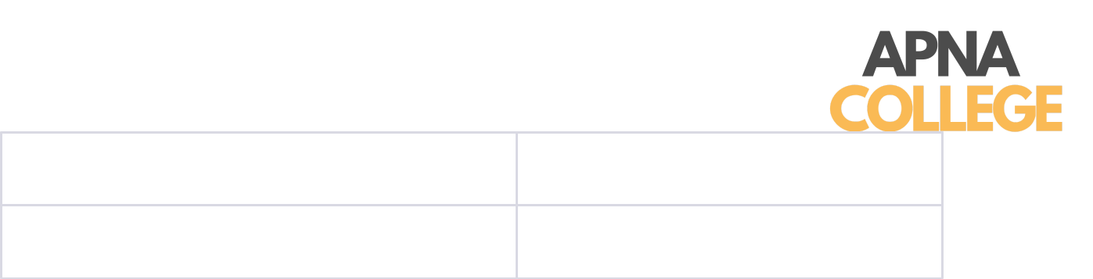

Keyboard

In this full outer join example, all rows from both tables are included in the result. Both non-matching rows from the Customers and Orders tables are represented with NULL values.

3) Cross Join

A cross join, also known as a Cartesian product, is a type of join operation in a Database Management System (DBMS) that combines every row from one table with every row from another table.

Unlike other join types, a cross join does not require a specific condition to match rows between the tables. Instead, it generates a result set that contains all possible combinations of rows from both tables.

Cross joins can lead to a large result set, especially when the participating tables have many rows.

Syntax:

SELECT columns

FROM table1

CROSS JOIN table2;

In this syntax:

- columns refers to the specific columns you want to retrieve from the cross-joined tables.

- table1 and table2 are the names of the tables you want to combine using a cross join.

Example: Consider two tables: Students and Courses.

Students Table:

StudentID

1

StudentName

Alice

2

Bob


Courses Table:

CourseID

101

CourseName

Maths

102

Science

Cross Join Query:

SELECT Students.StudentName, Courses.CourseName

FROM Students

CROSS JOIN Courses;

Result:

StudentName | CourseName
Alice | Maths
Alice | Science
Bob | Maths
Bob | Science

In this example, the cross join between the Students and Courses tables generates all possible combinations of rows from both tables. As a result, each student is paired with each course, leading to a total of four rows in the result set.

4) Self Join

A self join involves joining a table with itself.

This technique is useful when a table contains hierarchical or related data and you need to compare or analyse rows within the same table.

Self joins are commonly used to find relationships, hierarchies, or patterns within a single table.

In a self join, you treat the table as if it were two separate tables, referring to them with different aliases.

Syntax:

The syntax for performing a self join in SQL is as follows:

SELECT columns

FROM table1 AS alias1

JOIN table1 AS alias2 ON alias1.column = alias2.column;

In this syntax:

- columns refers to the specific columns you want to retrieve from the self-joined table.

- table1 is the name of the table you're joining with itself.

- alias1 and alias2 are aliases you assign to the table instances for differentiation.

- column is the column you use as the join condition to link rows from the same table.

Example: Consider an Employees table that contains information about employees and their managers.

Employees Table:

EmployeeID | EmployeeName | ManagerID
1 | Alice | 3
2 | Bob | 3
3 | Carol | NULL
4 | David | 1
Self Join Query:

SELECT e1.EmployeeName AS Employee, e2.EmployeeName AS Manager FROM Employees AS e1
JOIN Employees AS e2 ON e1.ManagerID = e2.EmployeeID;

Result:

Employee

Manager

Alice

Bob

David

Carol
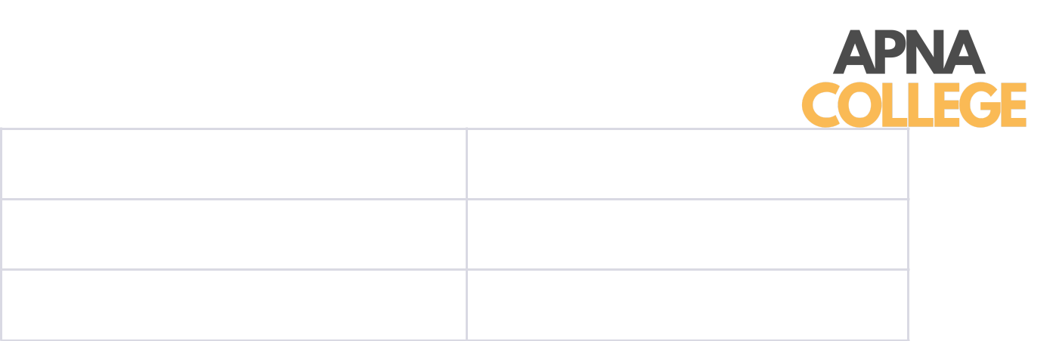

Carol

Alice

In this example, the self join is performed on the Employees table to find the relationship between employees and their managers. The join condition connects the ManagerID column in the e1 alias (representing employees) with the EmployeeID column in the e2 alias (representing managers).

SET OPERATIONS

Set operations in SQL are used to combine or manipulate the result sets of multiple SELECT queries.
They allow you to perform operations similar to those in set theory, such as union, intersection, and difference, on the data retrieved from different tables or queries.

Set operations provide powerful tools for managing and manipulating data, enabling you to analyse and combine information in various ways.

There are four primary set operations in SQL:

  - UNION

  - INTERSECT

  - EXCEPT (or MINUS)

  - UNION ALL

- UNION:

The UNION operator combines the result sets of two or more SELECT queries into a single result set.
It removes duplicates by default, meaning that if there are identical rows in the result sets, only one instance of each row will appear in the final result.

Example:

Assume we have two tables: Customers and Suppliers.

Customers Table:

CustomerID

1

CustomerName

Alice

2

Bob

Suppliers Table:

SupplierID

101

SupplierName

SupplierA

102

SupplierB

UNION Query:

SELECT CustomerName FROM Customers

UNION

SELECT SupplierName FROM Suppliers;

Result:

CustomerName

Alice

Bob

SupplierA

SupplierB

2. INTERSECT:

The INTERSECT operator is used to return the common records from two or more SELECT statements

It only returns distinct rows that appear in all result sets.

Table Structure:
employees
id | name
1 | Alice
2 | Bob
3 | Charlie
4 | David
managers
id | name
1 | Alice
2 | David
3 | Eve

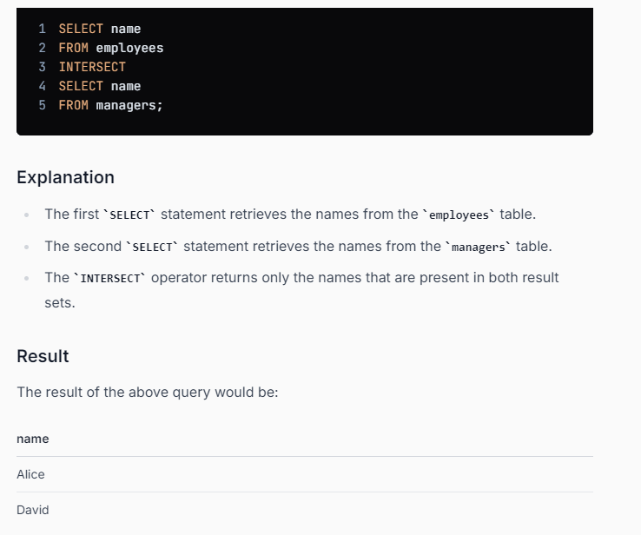.

3. EXCEPT (or MINUS):

The EXCEPT operator (also known as MINUS in some databases) returns the distinct rows that are present in the result set of the first SELECT query but not in the result set of the second SELECT query.

Example: Using the same tables as before.

SELECT CustomerName FROM Customers

EXCEPT

SELECT SupplierName FROM Suppliers;

Result:

CustomerName

Alice

Bob

In this example, the names "Alice" and "Bob" are customers but not suppliers, so they appear in the result set.

4. UNION ALL:

The UNION ALL operator performs the same function as the UNION operator but does not remove duplicates from the result set. It simply concatenates all rows from the different result sets.
Example: Using the same tables as before.

SELECT CustomerName FROM Customers

UNION ALL

SELECT SupplierName FROM Suppliers;

Result:

CustomerName

Alice

Bob

SupplierA

SupplierB

Difference between Set Operations and Joins

Aspect | Set Operations | Joins

 | Combine data from related
Purpose | Manipulate result sets based on
Purpose | tables based on specifed
 | set theory principles.
 | conditions.

Data Source | Result sets of SELECT queries. | Tables that are related by
 | Result sets of SELECT queries. | common columns.
 | Combine rows from different | Combine rows from different
Combining Rows | result sets. May remove | tables based on specifed
 | duplicates. | conditions.
 | Require the SELECT queries to | Can combine columns from
 | have the same number of output | Can combine columns from
Output Columns | have the same number of output | different tables, regardless of
Output Columns | columns and compatible data | different tables, regardless of
 | columns and compatible data | data types or column numbers.
 | types. | data types or column numbers.
Common | UNION, INTERSECT, EXCEPT | INNER JOIN, LEFT JOIN, RIGHT
Operations | (MINUS). | JOIN, FULL JOIN.
Conditional | No specifc join conditions are | Require specifed join conditions
Requirements | required. | for combining data.
Handling | UNION removes duplicates by | Joins do not inherently handle
Handling | UNION removes duplicates by | duplicates; it depends on the join
Duplicates | default. | duplicates; it depends on the join
Duplicates | default. | type and data.

 | Useful for combining and | Used to retrieve and relate data
Usage Scenarios | analysing related data from | from different tables based on
 | different queries or tables. | their relationships.
Result Set | Result sets may have different | Result sets can have different
Result Set | column names, but data types and | column names, data types, and
Structure | column names, but data types and | column names, data types, and
Structure | counts must match. | counts.
Performance | Generally faster and less complex | Joins can be more complex and
Performance | Generally faster and less complex | resource-intensive, especially for
Considerations | than joins. | resource-intensive, especially for
Considerations | than joins. | larger datasets.

SUB QUERIES

Subqueries, also known as nested queries or inner queries, allow you to use the result of one query (the inner query) as the input for another query (the outer query).

Subqueries are often used to retrieve data that will be used for filtering, comparison, or calculation within the context of a larger query.

They are a way to break down complex tasks into smaller, manageable steps.

Syntax:

SELECT columns
FROM table

WHERE column OPERATOR (SELECT column FROM table WHERE condition);

In this syntax:

- columns refers to the specific columns you want to retrieve from the outer query.

- table is the name of the table you're querying.

- column is the column you're applying the operator to in the outer query.

- OPERATOR is a comparison operator such as =, >, <, IN, NOT IN, etc.

- (SELECT column FROM table WHERE condition) is the subquery that provides the input for the comparison.

Example: Consider two tables: Products and Orders.

Products Table:

ProductID | ProductName | Price
1 | Laptop | 1000
2 | Smartphone | 500
3 | Headphones | 50

Orders Table:

OrderID | ProductID | Quantity
101 | 1 | 2
102 | 3 | 1

For Example: Retrieve the product names and quantities for orders with a total cost greater than the average price of all products.

SELECT ProductName, Quantity

FROM Products

WHERE Price * Quantity > (SELECT AVG(Price) FROM Products);

Result:

ProductName

Quantity

Laptop

2


Differences Between Subqueries and Joins:

Aspect | Subqueries | Joins
 | Retrieve data for filtering,
Purpose | comparison, or calculation | Combine data from related tables
Purpose | within the context of a larger | based on specified conditions.
 | query.
Data Source | Result of one query used as | Data from multiple related tables.
Data Source | input for another query. | Data from multiple related tables.
Combining Rows | Not used for combining rows; | Combines rows from different tables
Combining Rows | used to filter or evaluate data. | based on specified join conditions.
Result Set | Subqueries return scalar | Joins return multi-column result
Result Set | values, single-column results, | Joins return multi-column result
Structure | values, single-column results, | sets.
Structure | or small result sets. | sets.
Performance | Subqueries can be slower and | Joins can be more efficient for
Performance | less efficient, especially when | Joins can be more efficient for
Considerations | less efficient, especially when | combining data from multiple tables.
Considerations | dealing with large datasets. | combining data from multiple tables.
 | Subqueries can be easier to | Joins can become complex, but are
 | Subqueries can be easier to | more suited for handling large-scale
Complexity | understand for simple tasks or | more suited for handling large-scale
Complexity | understand for simple tasks or | data retrieval and combination
 | smaller datasets. | data retrieval and combination
 | smaller datasets. | tasks.
 | Subqueries can be used in | Joins are primarily used in the
Versatility | various clauses: WHERE, | Joins are primarily used in the
Versatility | various clauses: WHERE, | FROM clause for combining tables.
 | FROM, HAVING, etc. | FROM clause for combining tables.

SQL Trigger
SQL triggers are database objects that automatic execution of a set of SQL statements when specific database events, such as INSERT, UPDATE, or DELETE operations, occur.
Triggers are commonly used to maintain data integrity, track changes, and enforce business rules automatically, without needing manual input.

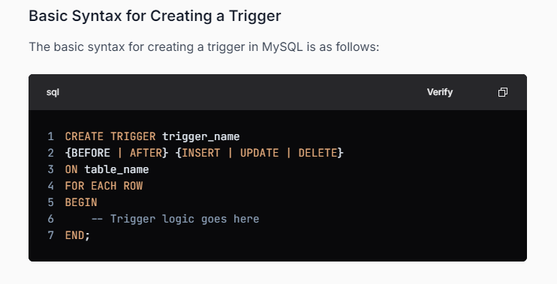

What is a Candidate Key?
In simple terms, a candidate key is a possible key that can uniquely identify each record in a table, and there may be multiple candidate keys for a table.
Key Properties of a Candidate Key:
- Uniqueness: The value of the candidate key must uniquely identify each row in the table.
- Minimality: If any attribute of the candidate key is removed, it will no longer be able to uniquely identify a row.

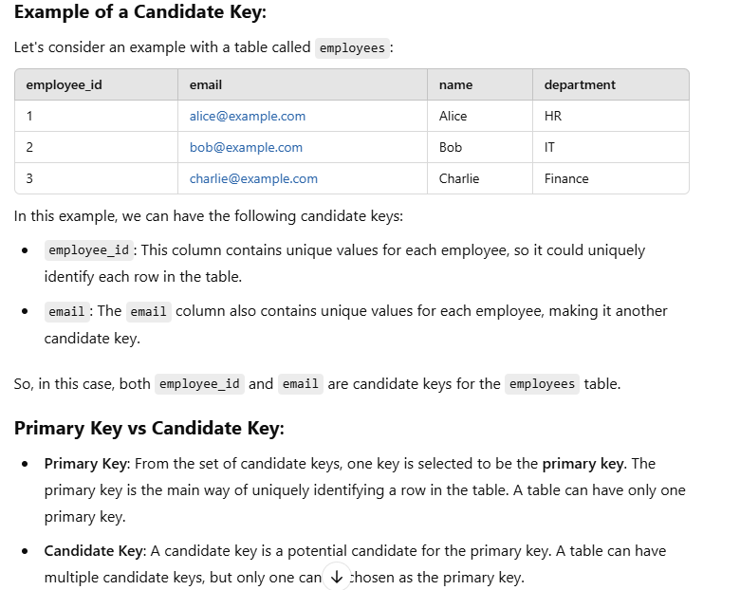

What is Normalization?
- Normalization is the process of organizing the data in the database.
- Normalization is used to minimize the redundancy from a relation or set of relations. It is also used to eliminate undesirable characteristics like Insertion, Update, and Deletion Anomalies.
- Normalization divides the larger table into smaller and links them using relationships.
- The normal form is used to reduce redundancy from the database table.

Why do we need Normalization?
The main reason for normalizing the relations is removing these anomalies. Failure to eliminate anomalies leads to data redundancy and can cause data integrity and other problems as the database grows.

Data modification anomalies can be categorized into three types:
- Insertion Anomaly: Insertion Anomaly refers to when one cannot insert a new tuple into a relationship due to lack of data.
- Deletion Anomaly: The delete anomaly refers to the situation where the deletion of data results in the unintended loss of some other important data.

- Updatation Anomaly: The update anomaly is when an update of a single data value requires multiple rows of data to be updated.

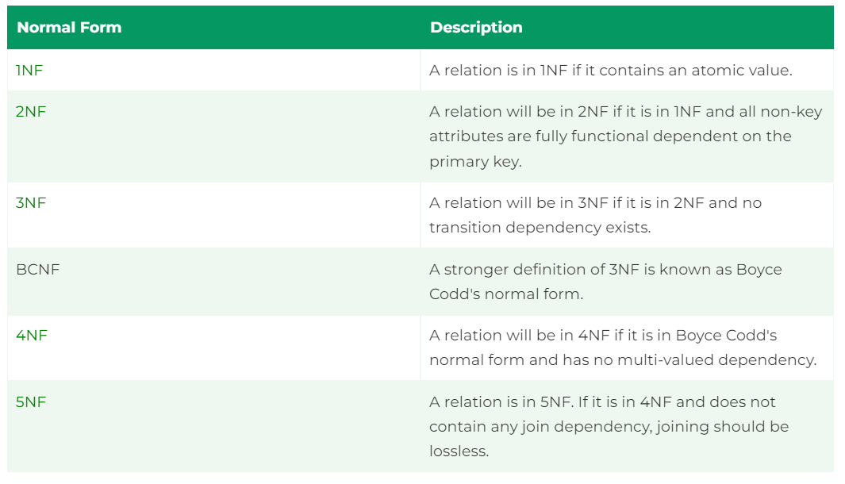

Queries
Find the second Highest Salery in Employee Table
SELECT * FROM `employees` Order BY salery desc Limit 1,1;

List all the employes who have been hired in laste year
Select * from employees Where YEAR(hireDate) = YEAR(CURDATE()) - 1;

From The Average Salery OF each department
SELECT d.departmentName, AVG(e.salery) from employees e Inner Join departments d ON e.departmentId = d.dID GROUP BY departmentName;

List all departments along with count employees in each department
SELECT d.departmentName, count(*) FROM `employees` e Inner Join departments d on e.departmentID = d.dID GROUP BY departmentName;

